[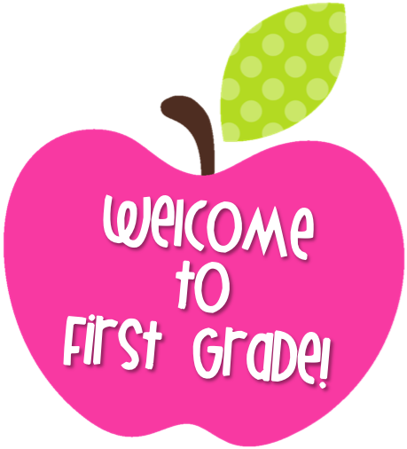](https://www.google.com/url?sa=i&rct=j&q=&esrc=s&source=images&cd=&cad=rja&uact=8&ved=2ahUKEwjEpc-999vbAhVKwFkKHULUDFYQjRx6BAgBEAU&url=https://www.henry.k12.va.us/domain/1956&psig=AOvVaw37PN8kmI5nJmlQ0UByrGZd&ust=1529367346039543)`

Dear First Grade Students and Families,

Welcome back to a new school year! Last school year was certainly challenging but the children adjusted beautifully. This new school year brings exciting opportunities and challenges that your child will enjoy engaging in. Your child will study reading, phonics, writing, math, science, and social studies. He/she will begin to write, read and solve challenging math problems independently. We promise to provide your child with a safe, challenging, and happy school year!

We will need your help to make sure your child truly thrives in first grade. Successful students get support from home and at school. For this reason, communication between students, parents, and teachers is essential. We encourage parents to contact us by phone, email, or Class Dojo (see attached for invitations to Class Dojo) regarding any questions or concerns about your child’s progress. We would be happy to schedule a virtual conference with you and we look forward to seeing everyone at the beginning of the school year!

Sincerely,

First Grade Teachers

Ms. Belizaire

[ebelizaire@yonkerspublicschools.org](mailto:ebelizaire@yonkerspublicschools.org)

Mrs. Branley

[bbranley@yonkerspublicschools.org](mailto:bbranley@yonkerspublicschools.org)

Ms. Grady

[agrady@yonkerspublicschools.org](mailto:agrady@yonkerspublicschools.org)

Class Dojo invitation link –

https://www.classdojo.com/invite/?c=C6QSZN2